Sample output 1
Threads used = 4

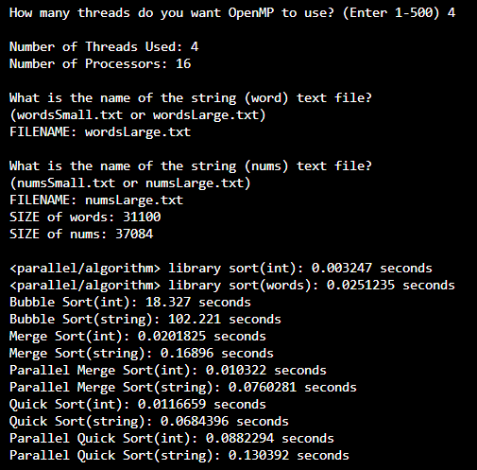

a. Why do you think you got the results that you got?
By only using 4 threads it took the algorithms longer to sort the files because they weren't maximizing their parallel processing at this thread count.

b. What algorithm was the fastest out of the algorithms you implemented?
Merge sort was able to sort the (int) file the fastest but quick sort had the best overall times across both files.

c. What algorithm was the slowest?
Bubble sort is consistently the slowest sorting algorithm.

d. How does your results compare to the sample output provided?
All of the results from the sorting algorithms match within a small margin of error of the sample output except bubble sort where my results show faster sort times for the (int) file but slower sort times for the (string) file.

Sample output 2

Threads used = 20

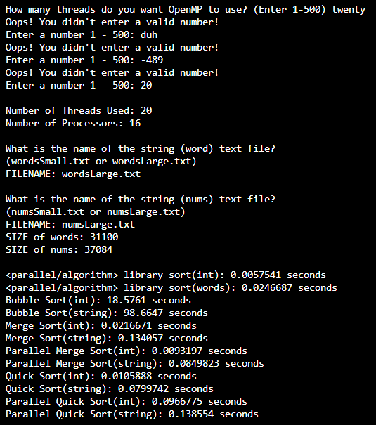

a. Why do you think you got the results that you got?
The results shifted in a direction up or down in time very slightly due to the thread count increasing.

b. How does it compare to the sample output provided?
Similarly to the first set of results, bubble sort had different runtimes while the others matched very closely.

Sample output 3

Threads used = 500

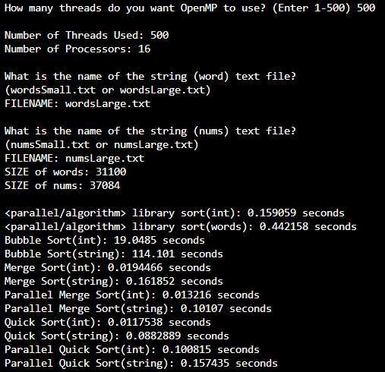

a. Why do you think you got the results that you got?
The results in this output have significantly higher times because there is major overhead involved in trying to use 500 threads for the sorting algorithms.

b. How does it compare to the sample output provided?
Once again, with the same discrepancies in bubble sort, the others match the sample output very closely.

Sample output 4 (optimization of threads used for bubble sort)
Threads used = 16

